**Online Apply for job (JOB HUT)**



**SUPERVISED BY:**

**Dr.Nadeem Akthar**

**SUBMITTED BY:**

**Muhammad Ishfaq**

**Roll No: 237**

**Session (2012-2016)**

**IN THE PARTIAL FULFILLMENT OF THE REQUIREMENTS FOR THE DEGREE OF (BSIT)**

**DEPARTMENT OF COMPUTER SCIENCE & IT**

The Islamia University of Bahawalpur





The Holy Quran

In the name of Allah the most compassionate the most merciful

**Please be to Allah, Lord of the World**

**The Beneficent, The Merciful,**

**Lord of the Day of Judgment.**

**Thee (Alone) We Worship, And**

**Thee (Alone) We Ask for Help.**

**Show Us the Straight path.**

**The path of those, whom thou hast favored,**

**Not (the path) of those who Earn thine wrath nor of those who go Astray.**

**(Ameen)**



Saying of Holy Prophet (S.A.W)

“Knowledge of Allah Is capital

Reason Is the Root of my father

Love is foundation

Enthusiasm is my horse

Remembrance of Allah is my friend

Firmness is my treasure

Sorrow is my companion

Science is my weapons

Patience is my mantle

Poverty is my pride

Devotion is my art

Convocation is my power

Truth is my redeemer

Obedience is my sufficiency

Struggle is my manner

And

My pleasure is my prayer”.

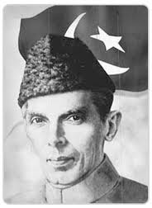

Quid-e-azam Muhammad Ali jinah

**.** When you have got that light of knowledge by means of education and when you have made yourselves strong economically and industrially, then you have got to prepared yourselves for your defense -- defiance against external aggression and to maintain internal security.

 (Presidential address at the conference of the Punjab Muslim Students Federation, March 2, 1941)

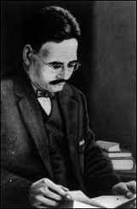

Dr.Allama Muhammad Iqbal

*“If you seek freedom by giving away your Imaan, faith and deen, then you will be destroyed in dunya and akhira! The modern Zionist civilization is again gathering its forces to invade Muslim lands. Muslims have to trust upon Allah (swt) alone…….. “*

**OPENING**

**In the name of**

ALLAH

**The most Beneficent,**

**The most Merciful**

***“*Guide us (O, Allah) to the path that is straight.**

**That path of those you have been blessed**

**Not of those who have earned your worth**

**Not those who have gone astray”.**

***(*Al-Fatiah 5-7)**

**AUTHOR’S DECLARATION**

I, **Muhammad Ishfaq**, in the Department of Computer science & IT at The Islamia University of Bahawalpur do here by solemnly declare that the project entitled, **“ online apply for job (job hut)”** submitted by us in partial fulfillment of the requirement of degree of **BSIT** is our original work. We solemnly declare that this is our original work and has not been submitted or published earlier and also shall not be submitted in future. It shall also not be submitted to obtain any degree to any other university or institution.

**Student Name**

**APPROVAL CERTIFICATE**

This project entitled **“online apply for job (job hut)”** submitted by Student Name is hereby approved in the partial fulfillment of the requirements for the degree of BSIT.

**Supervisor: ______________________**

**External Examiner: ______________________**

**Chairman: ______________________**

**Date: ______________________**

**DEDICATED TO**

**ALMIGHTY ALLAH,**

**HOLLY PROPHET (PBUH),**

**MY LOVING PARENTS,**

**AND**

**MY RESPECTED TEACHER**

**Dr.Nadeem Akthar**

**FINAL APPROVAL**

It is to certify that we have gone through this Final Project report that is submitted by Muhammad Ishfaq Roll no.237. BSIT, Session 2012-2016. It is our judgment that project and report is of sufficient standard to warrant its acceptance by The Islamia University of Bahawalpur for awarding the degree of bechloar in Information Technology.

**PANEL OF EXAMINERS:**

**Internal Examiner: _____________**

…

Lecturer,

Department of Computer Science & IT

The Islamia University of Bahawalpur

**External Examiner: _____________**

_________________

Assistant Professor

Department of Computer Science & IT

The Islamia University of Bahawalpur,

**Head of Department: _____________**

…  
Lecturer

Department of Computer Science & IT

The Islamia University of Bahawalpur

**ACKNOWLEDGEMENT**

All praises for Almighty Allah, who enables us to know about certain unknown things in the universe and helps us to overcome a lot of difficulties. All respect for Holy Prophet Muhammad (PBUH) who clearly mentioned the difference of right and wrong path, to ensure the success in our lives.

We are deeply indebted and wish our utmost appreciation and gratitude to our research supervisor **Sir.Nadeem akthar** for his encouragement, technical discussion, inspiring guidance, remarkable suggestions, keen interest and constructive criticism which enabled us to complete this research study.

We cannot find proper words to express our heartiest gratitude to our Loving Parents, and our respected teachers, whose chain of prayers, cooperation have created incredible impression in our lives.

In the end we are again much thankful to Almighty ALLAH who enabled us to complete our research work. Alhamdulillah.

**Student Name**

**Contents ________________________________________________________________________**

Chapter 1 Introduction 1.1 Introduction of Project

1.2 Techniques Used

Chapter 2 Requirement Analysis

2.1 System Requirement Specification

2.2 Construction and Limitation

Chapter 3 Object Oriented Design Analysis

3.1 Use Case Diagram

3.2 Activity Diagram

3.3 Sequence Diagram

Chapter 4 Database Analysis and Design

4.1 System Overview

4.2 Process Flow Diagram

4.2.1 Context Diagram

4.2.2 Level Zero Diagram

4.3 Entities & Attributes

4.4 E-R Diagram

4.5 Normalized Tables

4.6 Database Diagram

Chapter 5 Interfaces Snap Shots

Reference…………



**Introduction**

* **What is JOB HUT?**

This project is about for jobs opportunity for unemployed people. We are introducing different types of jobs for unemployed people where they can get access in this website. They can apply for this job by application form and for is available here.

**1.2) Introducing online applies for job (JOB HUT) System:**

This system is basically the benefit of the unemployed people for finding jobs of different forms in one site. This site provide briefly information in future and defines the all data about in my favorite country Pakistan and remove the unemployment in my country.

**1.3) Project Scope:**

* The scope of Web-Based School Management System is:

A person should be able to

* Every time check update related to jobs.
* Broadcast any news to the website viewers.
* Should be able to Contact the people for unemployed using website service
* Should be able to search any record anytime and print it through printer.

**1.4) Problem Statement**

**SECTION I:**

**Earlier System**

Earlier the Online job apply system was manual and it was controlled by only one or two relevant persons, if they leave the apply for job/organization then the whole system of the school is paralyzed.

**SECTION II**

**Drawbacks of Earlier System**

The main drawback is that it was the wastage of time and company owners cannot understand the way of working of the managers, now this whole system can be controlled through this web-based software application.

**1.5) Working of System Proposal:**

Our main goal was to develop online website that will help the user to

Provide the online system to create communication platform between parents (viewers) and students.

Gives ease to the administrator of the website to broadcast any gallery images and news anytime to the website, so that any viewer (public) can view it.

Give easiness to parents.

Need to keep help of owners of the website.

* **Advantages of Web-Based School Management System:**

As we are developing system for the applying jobs, we have kept in mind all the advantages which they are looking for. Some of advantages are described below:

* Quick to do.
* No need to travel anywhere.
* Could be cheaper.
* Can access more information and find other things online.
* Most important that system is user friendly and there is no loss of data without permission of user.

**1.6) Tools & Technologies:**

This system is developed by using

* Xampp
* Dreamweaver CS6
* Visual Light box
* Adobe Photoshop



**Requirement Analysis**

**System Requirements Specification:**

A **System Requirements Specification** (abbreviated SyRS when need to be distinct from a Software **Requirements Specification** SRS) is a structured collection of information that embodies the **requirements** of a **system**.

A [business analyst](https://en.wikipedia.org/wiki/Business_analyst), sometimes titled [system analyst](https://en.wikipedia.org/wiki/System_analyst), is responsible for analyzing the business needs of their clients and stakeholders to help identify business problems and propose solutions. Within the [systems development life cycle](https://en.wikipedia.org/wiki/Systems_development_life_cycle) domain, the BA typically performs a liaison function between the business side of an enterprise and the information technology department or external service providers.

**Constraints and Limitation:**

Project limitations may influence how you manage your project and may even determine whether or not you (and your project’s drivers and supporters) decide to proceed with your project. Project limitations typically fall into several categories. By recognizing these categories, you can focus your investigations and thereby increase the chances that you’ll discover all limitations affecting your project.

Your project’s drivers and supporters may have preset expectations or requirements in one or more of the following categories:

* **Results:** The products and effect of your project. For example, the new product must cost no more than $300 per item to manufacture, or the new book must be fewer than 384 pages in length.
* **Time frames:** When you must produce certain results. For example, your project must be done by June 30. You don’t know whether it’s possible to finish by June 30; you just know that someone expects the product to be produced by then.
* **Resources:** The type, amount, and availability of resources to perform your project work. Resources can include people, funds, equipment, raw materials, facilities, information, and so on. For example, you have a budget of $100,000; you can have two people full time for three months; or you can’t use the test laboratory during the first week in June.
* **Activity performance:** The strategies for performing different tasks. For example, you’re told that you must use your organization’s printing department to reproduce the new users’ manuals for the system you’re developing. You don’t know what the manual will look like, how many pages it’ll be, the number of copies you’ll need, or when you’ll need them. Therefore, you can’t know whether your organization’s printing department is up to the task. But at this point, you do know that someone expects you to have the printing department do the work.

Be careful of vague limitations; they provide poor guidance for what you can or can’t do, and they can demoralize people who have to deal with them. Here are some examples of vague limitations and how you can improve them:

* **Time frame limitation:**
  + **Vague:** “Finish this project as soon as possible.” This statement tells you nothing. With this limitation, your audience may suddenly demand your project’s final results — with no advance warning.
  + **Specific:** “Finish this project by close of business June 30.”
* **Resource limitation:**
  + **Vague:** “You can have Laura Webster on your project part time in May.” How heavily can you count on her? From Laura’s point of view, how can she juggle all her assignments in that period if she has no idea how long each one will take?
  + **Specific:** “You can have Laura Webster on your project four hours per day for the first two weeks in May.”

Determining limitations is a fact-finding mission, so your job is to identify and examine all possible sources of information. You don’t want to miss anything, and you want to clarify any conflicting information. After you know what people expect, you can determine how (or whether) you can meet those expectations. Try the following approaches:

* **Consult your audiences.** Check with drivers about limitations regarding desired results; check with supporters about limitations concerning activity performance and resources.
* **Review relevant written materials.** These materials may include long-range plans, annual budgets and capital appropriations plans, benefit-cost analyses, feasibility studies, reports of related projects, minutes of meetings, and individuals’ performance objectives.
* **When you identify a limitation, be sure to note its source.** Confirming a limitation from different sources increases your confidence in its accuracy.

**TOOLS REQUIRED**

* Apache Webserver Version 2.2.22
* PHP Script Language Version 5.3.13
* MYSQL Database Manager Version 5.5.24
* Adobe Dreamweaver Version CS 6
* Mozilla Firefox
* Google Chrome

**2.1 Details about Tools:**

**2.1.1 PHP:**

**2.1.1.1 What is PHP?**

PHP (PHP Hypertext Preprocessor) is a reflective programming language originally designed for producing dynamic web pages. PHP is used mainly in server-side scripting but can use for a command line interface or in standalone graphical application.

The main implementation is produced by “The PHP Group” and released under the PHP License. It is considered to be free software by the free Software Foundation. This implementation serves to define a de facto standard for PHP as there is no formal specification.

On July 13, 2004, PHP 5 was released powered by the new Zend Engine ||.PHP 5 included new features such as:

**2.1.1.2 Feature of PHP**

Robust support for object-Oriented Programming. The PHP Data Objects extension which defines a lightweight and consistent interface for accessing databases.

* Performance enhancements taking advantage of the new engine.
* Better support for MYSQL through a completely rewritten extension.
* Embedded support for SQLite.
* Integrated SOAP support.
* Data integrators.
* Error handling through exception.

**2.1.1.3 Server-side Scripting**

Originally designed to create dynamic web pages PHP’s principal focus is server-side scripting. While running the PHP parser with a web server and web browser, the PHP model can be compared to other server-side scripting languages such as Microsoft’s ASP.NET system, Sun Microsystem’s JavaServer Pages, mod_pearl and the Ruby on Rails framework, as they all provide dynamic content to the client from a web server. To more directly compete with the “Framework” approach taken by these systems, Zend is working on the Zend Framework- emerging (as of Junen 2006) set of PHP building blocks and best practices; other PHP frameworks along the same lines include CakePHP,PRADO and Symfony.

The LAMP architecture has become popular in the web industry as a way of deploying inexpensive ,reliable, scalable, secure web applications. PHP is commonly used as the in this bundle alongside Linux, Apache and MySQL. PHP can be used with a large number of relational database management systems, runs on all of the most popular web servers and is available for many different operating systems. This flexibility means that PHP has a wide installation base across the internet; over 19 million internet domains are currently hosted on servers PHP installed.

**Cross-Platform:**

You can run most PHP code, without alteration, on computers running many different operating systems. A PHP script that runs on Linux will generally run on Windows as well.

**HTML-Embedded:**

PHP code is written in files containing a mixture of PHP instructions and HTML code.

**Server-Side:**

The PHP programs we write are run on a server – specifically, a web server.

**2.2 A Web Scripting Language:**

We run PHP programs via a web browser. We access the web server on which they reside, and this runs the program, sending any resulting output back to the browser. This is different from a script written in other languages like Perl or C -- instead of writing a program with lots of commands to output HTML, you write an HTML script with some embedded code to do something (in this case, output some text). The PHP code is enclosed in special start and end tags that allow you to jump into and out of "PHP mode".

# PHP 4:

By the winter of 1998, shortly after PHP 3.0 was officially released, Andi Gutmans and Zeev Suraski had begun working on a rewrite of PHP's core. The design goals were to improve performance of complex applications, and improve the modularity of PHP's code base. Such applications were made possible by PHP 3.0's new features and support for a wide variety of third party databases and APIs, but PHP 3.0 was not designed to handle such complex applications efficiently.

The new engine, dubbed 'Zend Engine' (comprised of their first names, Zeev and Andi), met these design goals successfully, and was first introduced in mid-1999. PHP 4.0, based on this engine, and coupled with a wide range of additional new features, was officially released in May 2000, almost two years after its predecessor, PHP 3.0. In addition to the highly improved performance of this version, PHP 4.0 included other key features such as support for many more Web servers, HTTP sessions, output buffering, more secure ways of handling user input and several new language constructs.

PHP 4 is currently the latest released version of PHP. Work has already begun on modifying and improving the Zend Engine to integrate the features which were designed for PHP 5.0.

Today, PHP is being used by hundreds of thousands of developers (estimated), and several million sites report as having it installed, which accounts for over 20% of the domains on the Internet.

# PHP 5:

The future of PHP is mainly driven by its core, the Zend Engine. PHP 5 will include the new Zend Engine 2.0. To get more information on this engine

# PEAR

PEAR, the PHP Extension and Application Repository (originally, PHP Extension and Add-on Repository) is PHP's version of foundation classes, and may grow in the future to be one of the key ways to distribute both PHP and C-based PHP extensions among developers.

# 2.3 What can PHP do?

PHP is mainly focused on server-side scripting, so you can do anything any other CGI program can do, such as collect form data, generate dynamic page content, or send and receive cookies. But PHP can do much more. There are three main fields where PHP scripts are used.

* **Server-side scripting.** This is the most traditional and main target field for PHP. You need three things to make this work. The PHP parser (CGI or server module), a web server and a web browser. You need to run the web server, with a connected PHP installation. You can access the PHP program output with a web browser, viewing the PHP page through the server.
* **Command line scripting.** You can make a PHP script to run it without any server or browser. You only need the PHP parser to use it this way. This type of usage is ideal for scripts regularly executed using cron (on *nix or Linux) or Task Scheduler (on Windows). These scripts can also be used for simple text processing tasks.
* **Writing Client-Side GUI Applications**: PHP is probably not the very best language to write windowing applications, but if you know PHP very well, and would like to use some advanced PHP features in your client-side applications you can also use PHP-GTK to write such programs. You also have the ability to write cross-platform applications this way. PHP-GTK is an extension to PHP, not available in the main distribution.

PHP can be used on all major operating systems, including Linux, many UNIX variants, Microsoft Windows, Mac OS, and probably others. PHP has also support for most of the web servers today. This includes Apache, Microsoft Internet Information Server, Personal Web Server, Netscape and iPlanet servers for the majority of the servers PHP has a module, for the others supporting the CGI standard, PHP can work as a CGI processor.

So with PHP, you have the freedom of choosing an operating system and a web server. Furthermore, you also have the choice of using procedural programming or object oriented programming, or a mixture of them. Although not every standard OOP feature is realized in the current version of PHP, many code libraries and large applications (including the PEAR library) are written only using OOP code.

With PHP you are not limited to output HTML. PHP's abilities include outputting images, PDF files and even Flash movies (using libswf and Ming) generated on the fly. You can also output easily any text, such as XHTML and any other XML file. PHP can auto generate these files, and save them in the file system, instead of printing it out, forming a server-side cache for your dynamic content.

**Support for a wide range of database:**

One of the strongest and most significant features in PHP is its support for a wide range of databases. Writing a database-enabled web page is incredibly simple. The following databases are currently supported:

|  |  |  |
| --- | --- | --- |
| Adabas D | Ingres | Oracle (OCI7 and OCI8) |
| dBase | InterBase | Ovrimos |
| Empress | FrontBase | PostgreSQL |
| FilePro (read-only) | mSQL | Solid |
| Hyper wave | Direct MS-SQL | Sybase |
| IBM DB2 | MySQL | Velocis |
| Informix | ODBC | Unix dbm |

Additionally PHP supports ODBC, the Open Database Connection standard, so you can connect to any other database supporting this world standard.

PHP also has support for talking to other services using protocols such as LDAP, IMAP, SNMP, NNTP, POP3, HTTP, COM (on Windows) and countless others. You can also open raw network sockets and interact using any other protocol. PHP has support for the WDDX complex data exchange between virtually all Web programming languages. Talking about interconnection, PHP has support for instantiation of Java objects and using them transparently as PHP objects.

While using PHP in the e-commerce field, you'll find the Cybercash payment, CyberMUT, VeriSign Payflow Pro and CCVS functions useful for your online payment programs.

# 

**2.5 MySQL**

**2.5.1 What is MySQL?**

MySQL is an open source relational database management system (RDBMS) that uses structured Query Language (SQL), the most popular language for adding, accessing and processing the data in database. Because it is open source, anyone can download MySQL and tailor it to their needs in accordance with the general public license. MySQL is noted mainly for its speed, reliability and flexibility.

**2.5.2 Programming Languages that MySQL Supports:**

Libraries for accessing MySQL databases are available in all major programming languages with language-specific APIs. In addition, an ODBC interface called Modoc allows additional programming languages that support the ODBC interface to communicate with a MySQL database, such as ASP or ColdFusion. The MySQL server and official libraries are mostly implemented in ANSI C.

**2.5.3 Uses**

MySQL is popular for web applications and acts as the database component of the LAMP, MAMP, and WAMP platforms (Linux/Mac/Windows-Apache-MySQL-PHP/Perl/Python),and for open-source bug tracking tools like Bugzilla.Its popularity as a web application is closely tied to the popularity of PHP,which is often combined with MySQL and nicknamed the Dynamic Duo.it is easy to find many references that combine the two in websites and books (PHP and MySQL for Dummies, PHP and MySQL Bible, Beginning PHP and MySQL,etc.).PHP and MySQL are assential components for running the popular Word press blogging plateform.Wikipedia runs on mediaWiki software,which also uses PHP and a MySQL database.

**2.5.4 Platforms**

MySQL works on many different platforms---including AIX, BSDi, FreeBSD, HP-UX, GNU/Linux, Mac OS X, NetBSD, Novell NetWare, OpenBSD, OS/2 Warp, QNX, SGI IRIX, Solaris, SunOS, SCO OpenServer, SCO UnixWare, Tru64, Windows 95, Windows 98, Windows ME, Windows NT, Windows 2000, Windows XP, Windows Vista and Windows 7.A port of MySQL to OpenVMS is also available.

**2.6 Apache Server :**

**Introduction :**

Often reffered to as simply Apache, a public-domain open source Web server developed by a loosely-knit group of programmers. The first version of Apache, based on the NCSA http Web server was developed in 1995.

Core development of the Apache Web server is performed by a group of about 20 volunteer programmers, called the Apache Group. However, because the source code is freely available anyone can adopt server for specific needs and there is a large public library of Apache add-ons. In many respect, development of Apache is similar to development of the Linux operating system.

The original version of Apache was written for UNIX, but there are new versions that run under OS/2, Windows and other platforms.

The name is a tribute to the Native American Apache Indian tribe, a tribe well known for its endurance and skill in warfare. A common misunderstanding is that it was called the name a patchy server , or Apache server.

**2.6.1 What is phpMyAdmin ?**

PhpMyAdmin is a tool written in PHP intended to handle the administration of MySQL over the Internet. Currently it can creat and drop databases,creat/drop/alter tables, delete/edit/add fields, execute any SQL statement, and manage keys on fields.

**2.6.2 History :**

Tobias Ratschiller, then an IT consultant and later founder of the software company Maguma, started to work on a PHP-based web frontend to MySQL in 1998, inspired by Peter Kuppelwieser’s MySQL-Webadmin. When he gave up the project in 2000 because of lack of time, phpMyAdmin had already become one of the most popular PHP application and MySQL administration tools with a large community of users and contributors.it is also included in many Linux distributions.

In order to coordinate the growing number of patches, a group of three developers, Olivier Muller, Marc Delisle and Loic Chapeaux, registered the phpMyAdmin Project at SourceForge and took over the development in 2000.



**Object Oriented**

**Design Analysis**

**DATABASE DESIGN**

Database Design:

In our data flow diagram, we give names to data flows, processes and data stores. Although the names are descriptive of data, they do not drive details .So following DFD, our interest is to build some details of the contents of data flows, processes and data store. A data dictionary is a structured repository of data about data .It is a set of rigorous definitions of all DFD data elements and data structures.

These activities shall consist of:

® Designing appropriate data base structures to those identified persistent classes which identified during database design.

® Defining techniques and strategies for storing and retrieving persistent data in such a way that the performance criteria for the project are met.

Entity:

An **entity** is a thing or object of importance about which data must be captured. All things aren't entities—only those about which information should be captured.

Information about an entity is captured in the form of attributes and/or relationships. If something is a candidate for being an entity and it has no attributes or relationships, it isn't an entity.

Database entities appear in a data model as a box with a title. The title is the name of the entity.

Attributes:

An attribute of an object usually consists of a name and a value; of an element, a type or class name; of a file, a name and extension. An **attribute** is a specification that defines a property of an object, element, or file. It may also refer to or set the specific for a given instance of such.

For clarity, attributes should more correctly be considered metadata. An attribute is frequently and generally a property of a property.

However, in actual usage, the term attribute can and is often treated as equivalent to a property depending on the technology being discussed.

1. **Use Case Diagram**

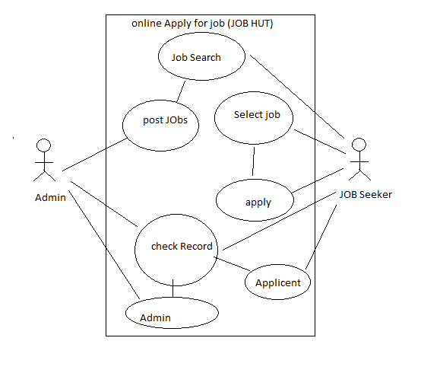

1. **Activity Diagram**

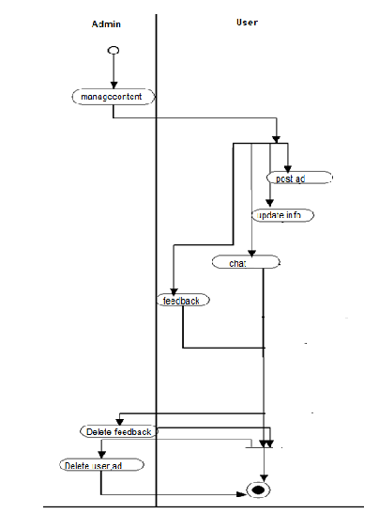

1. **Sequence Diagram**

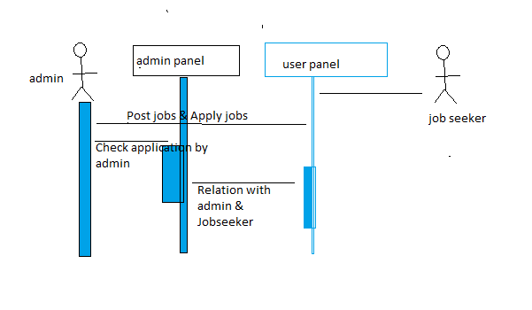



Database Analysis

And Design

Purpose:

* Specifies the software's operational characteristics
* Indicates the software's interfaces with other system elements
* Establishes constraints that the software must meet
* Provides the software designer with a representation of information, function, and behavior
  + This is later translated into architectural, interface, class/data and component-level designs
* Provides the developer and customer with the means to assess quality once the software is built

Overall Objectives:

* Three primary objectives
  + To describe what the customer requires
  + To establish a basis for the creation of a software design
  + To define a set of requirements that can be validated once the software is built
* All elements of an analysis model are directly traceable to parts of the design model, and some parts overlap

Analysis Rules of Thumb:

* The analysis model should focus on requirements that are visible within the problem or business domain
  + The level of abstraction should be relatively high
* Each element of the analysis model should add to an overall understanding of software requirements and provide insight into the following
  + Information domain, function, and behavior of the system
* The model should delay the consideration of infrastructure and other non-functional models until the design phase
  + First complete the analysis of the problem domain
* The model should minimize coupling throughout the system
  + Reduce the level of interconnectedness among functions and classes
* The model should provide value to all stakeholders
* The model should be kept as simple as can be

**Database Analysis Snap Shots:**

**Contact:**

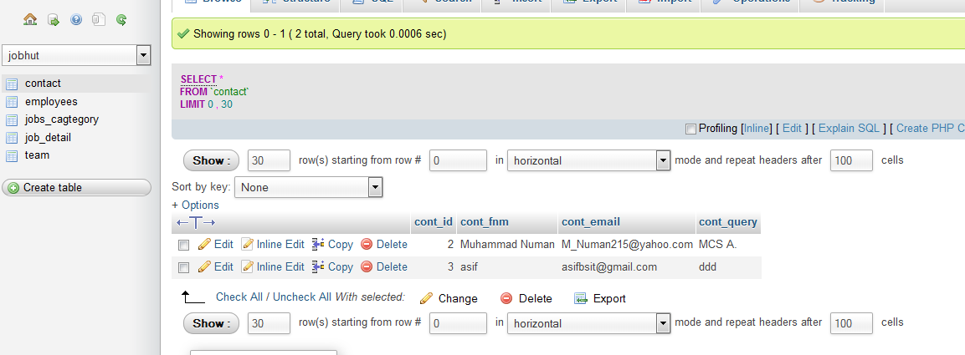

**Employees:**

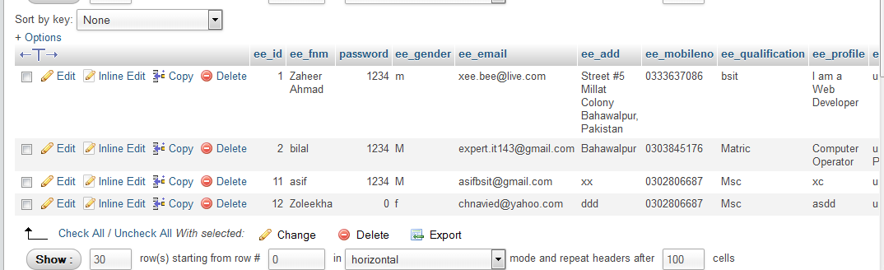

**Jobs Categories _employees:**

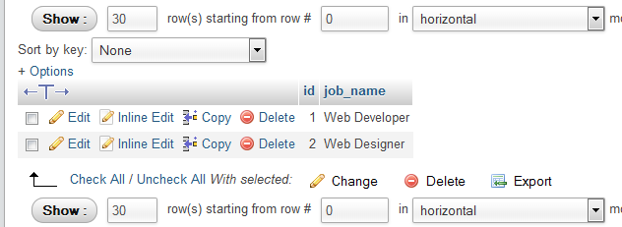

**Job Detail:**

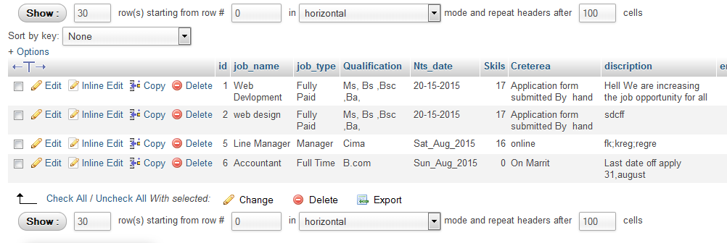

**Team (Admin & Password):**

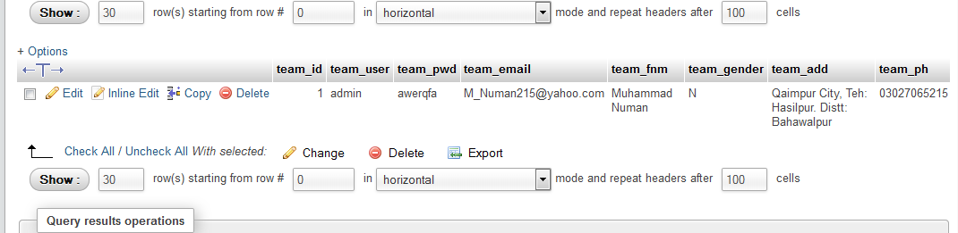



**System Implementation**

**TESTING**

Testing Strategy:

The development of web application involves a series of production activities where opportunities for injection of human fallibilities are enormous. Errors may begin to occur at a very inception of the process where the objectives may be erroneously or imperfectly specified. Because of human inability to perform and communicate with perfection, software development is accompanied by a quality assurance activity.

Testing Strategy:

The basic Strategies that are used for testing are following.

* Black box testing
* White box Testing
* Unit Testing
* System Testing
* Acceptance Testing

Black box Testing:

In Black Box testing only the functionality was tested without any regard to the code written. If the functionality, which was expected from a component, is provided then black box testing is completed. Black Box testing is also called as Behavioral testing because it tests the functional requirements of the software. Black Box testing enables to derive sets of input conditions that will fully exercise all functional requirements for a program. Black Box testing is not an alternative to white-box techniques. Rather it is complementary approach that is likely to uncover a different class of errors than white-box methods.

White Box Testing:

In white Box testing internal code written in every component was tested and it was checking that the code written is efficient in utilizing various resources of the system like memory or the utilizing of input output. White Box testing is a test case design method that uses the control structure of the procedural design to derive test cases. Logical errors and incorrect assumptions are inversely proportional to the probability that a program path will be executed.

Unit Testing:

In Unit testing I checked that the entire individual component is working properly. Before integration of the entire component unit testing is essential because it gives a confidence that all the component individually are working fine and ready to be integrated with the other once.

System Testing:

When all the units are working properly and unit testing was performed then came the time for system testing where we checked all the integrated components as a whole and looked for possible discrepancies, which could have arisen after the integration.

Acceptance Testing:

In acceptance testing the software was checked for completeness that it is ready. Normally the quality assurance department performs the acceptance testing that the software is ready and can be exported.

Debugging:

Debugging is not testing but it occurs always as a consequence of testing. It begins with execution of a test case. Results are assessed and lack of correspondence between expected and actual performance is encountered. Debugging is one of the more frustrating parts of programming. It has elements of problem solving or brainteasers coupled with the annoying recognition that you have made a mistake. While testing my software I found some errors, which I corrected in debugging modes. I found Syntax errors in Black box testing and Logical errors in white-box testing.

Syntax Errors:

These are caused by typographical errors & incorrect use of the Programming language.

Logic Errors:

These are caused by the incorrect use of the control structure. These errors were identified while testing procedure and were corrected in debugging mode.

## Screen Shots

### Login Page

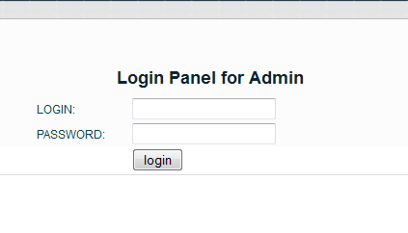

1.4.1. **Home Page:**

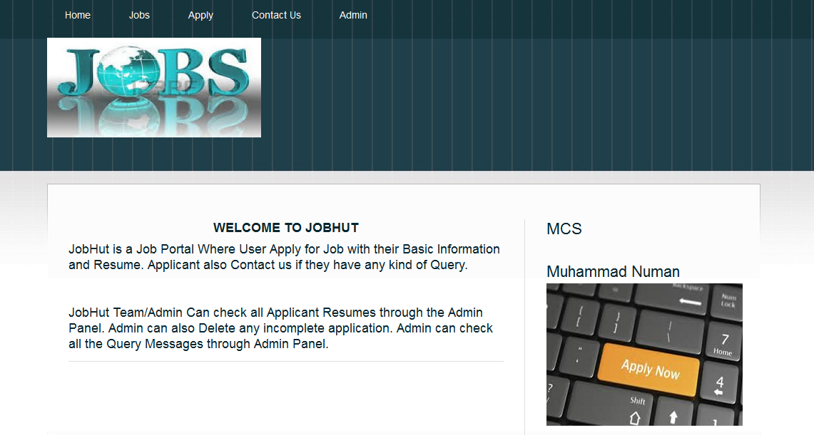

1.4.2. **Available Jobs:**

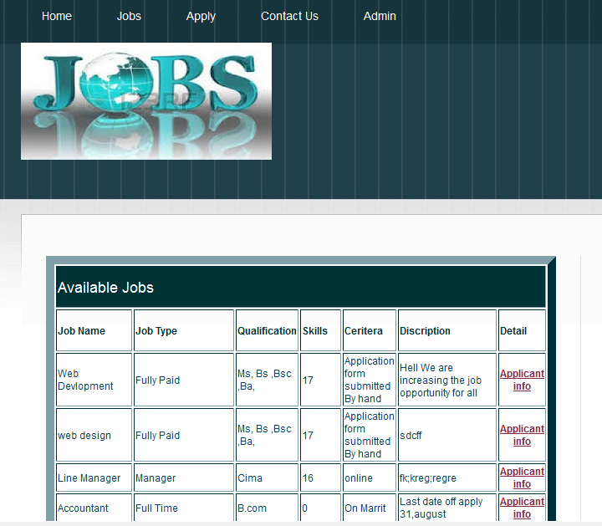

1**.4.3. Apply for the Job (Form)**

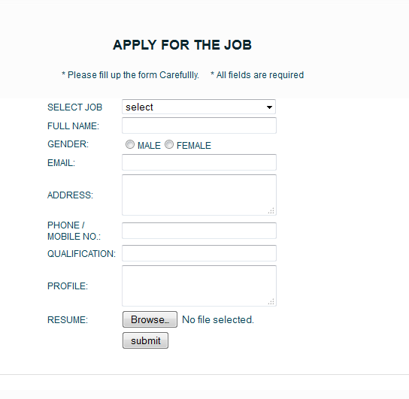

**1.4.4. Contact Form:**

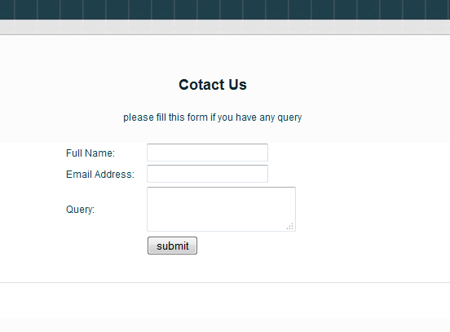

**1.4.5. Admin Panel:**

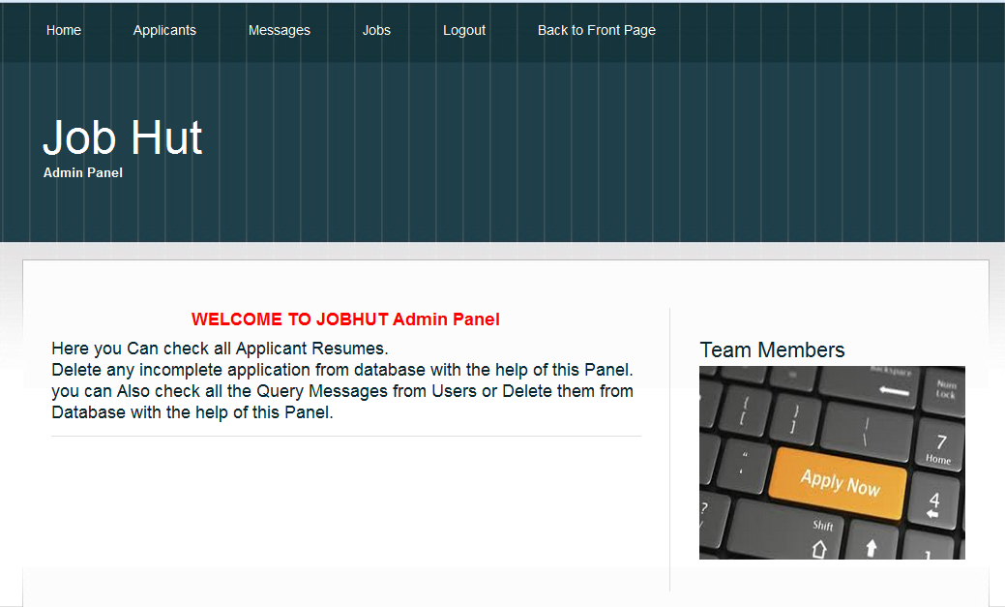

**1.4.6. Admin View all Applications:**

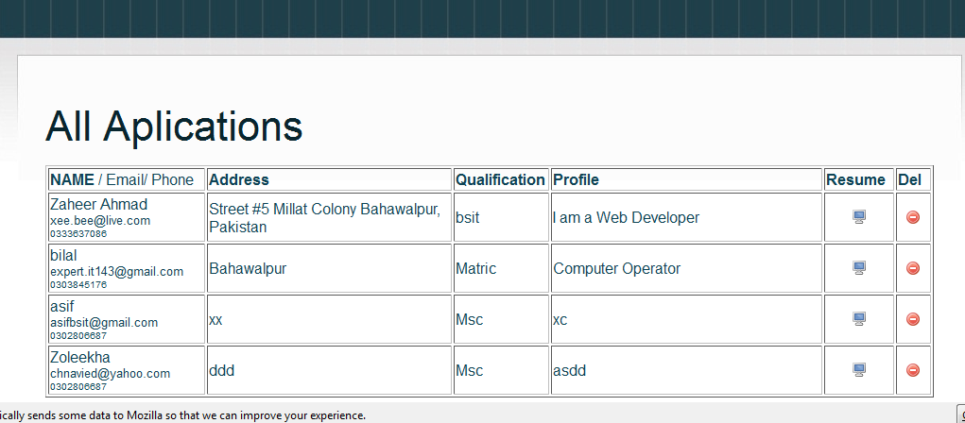

**1.4.7. All queries Messages:**

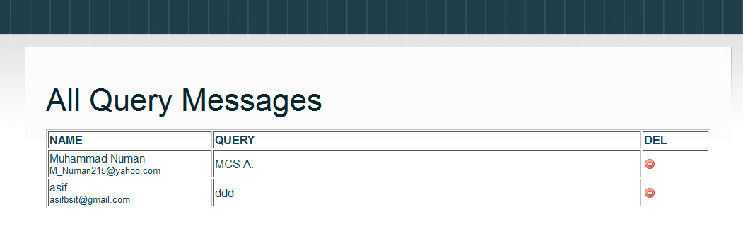

**1.4.8 . Job List:**

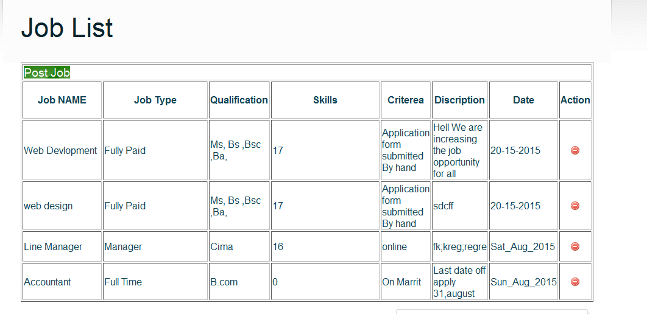

**1.4.9. Logout Admin Panel:**

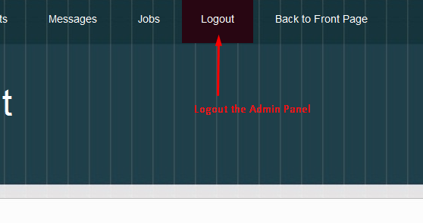

**References:**

**Websites_**

[http://www.w3schools.com/php/php intro.asp](http://www.w3schools.com/php/php%20intro.asp)

<http://www.tutorialspoint.com/php/>

<http://www.homeandlearn.co.uk/php/php.html>

<https://www.codecademy.com/courses/web-beginner-en-StaFQ/0/1?curriculum_id=5124ef4c78d510dd89003eb8>

**Books__**

**Beginning PHP 5.3**

**Programming PHP by O’REILLY®**

**PHP MySQL by Shakeel**

**Tutorials:**

A tutorial from ([www.onspot.pk](http://www.onspot.pk))

A tutorial from ([www.onlieustaad.com](http://www.onlieustaad.com))